PLEASE READ THIS AS A GUIDE TO THE SUBMISSION OF 2017 ASICS SMA CONFERENCE ABSTRACTS WANTING TO BE CONSIDERED FOR AWARDS

DO NOT INCLUDE AUTHORS / AFFILIATIONS IN THIS DOCUMENT - THESE WILL BE INCLUDED IN THE SUBMISSION PROCESS

INTRODUCTION
These instructions contain information about the submission of the maximum of 1 x A4 page paper for those wanting to be considered for awards, and provides you with a template for formatting for the one page paper required. All papers must fit the single page submission reflected in this document. Each paper must be electronically submitted via the Abstract Submission Portal by midnight AEST on Wednesday 12th April. These must be submitted as a PDF file and should include ONLY one figure OR one table. Files must not be larger than 5 MB. These longer papers will be used for the judging of awards and papers not meeting the required formatting will not be considered for awards.

The text format for this paper is Arial Narrow 10 font, single space, and a maximum of 1 x A4 page. Title must be fewer than 130 characters and spaces and is centred (denoted above). Do not include authors / affiliations – these will be included in the submission process. When submitting your abstract please use selected subheadings (bold). If included, the figure or table must be placed immediately after a paragraph. The figure captions should be below the figure the table heading above. Paragraph breaks should be single spaced as in this example and put double line spacing between paragraphs.

The page size should be set to A4 size (210 x 297 mm), with two columns of justified (left and right) text. Top and bottom margins should be 20 mm, while left and right margins should be 15 mm

The body of the paper should use the following sections: Introduction, Methods, Results and Discussion, and Conclusions.
The key to a good paper is to deliver a focused and explicit block of information. Do not try to publish all of your research findings here!

The Conference Organising Committee reserves the right to reject papers that do not adhere to the formatting guidelines in this document.

METHODS
The methods should be a brief explanation of what was done and how it was done. This may include design, participants (include sample size N), data collection, processing etc, [if it is a research project] or a brief explanation of what you did if the activity was program implementation, policy development, etc., or protocol used if a systematic review.

RESULTS AND DISCUSSION
Results should be explicit in describing the main findings or outcomes and preferably include some data. Do not submit a paper based on data yet to be collected or analysed. This discussion defines what the results mean (the implications) in terms of the background knowledge or practice (it answers the “so what?” question). “Results/ Findings will be discussed” is not discussion. Compare and contrast with the current evidence or context. Do not conclude that “future research is needed” unless explicitly described.

The table or figure used in the paper must be referenced in the text (Table 1, Figure 1), it must be self-explanatory either on the figure OR table itself or in the accompanying title / legend. Captions must be legible and in the same font as the text (Arial Narrow). Tables may extend across two columns when needed. To format the table for 2 columns select the table text and use “Format → Columns” to create a single column format.

Ensure that the text in any reduced figure remain legible if the size of the figure is reduced e.g. Figure 1 shows that the text “1 kg weight” has been substantially scaled down (Figure 1).
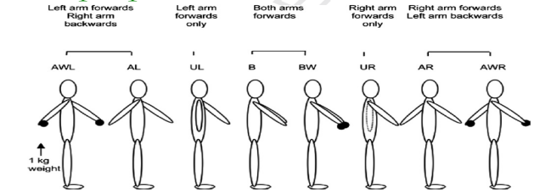

Figure 1: The biomechanical analysis of the hokey-pokey for the final dinner.

Any references in the citations should be denoted with numbers in brackets [1,3]. The format of the references need to be text (Arial Narrow 10pt) and not formatted from reference software such as Reference Manager© or Endnote©. References are to be placed at the bottom of the page. Keep numbers of references to a minimum. Standard journal abbreviations should be used and first author et al for references with more than 2 authors. Book and journal titles should be in italics.

CONCLUSIONS
In order to be considered for an award, you must provide both a 400 word abstract, this additional one page paper and ensure all award requirements are met. Award short listing is based on the quality of the paper at the time of submission. In the event that an incomplete submission is received, it will be withheld from acceptance until the authors supply all required components or the deadline of midnight AEST on Wednesday 13th April, 2016 passes. Please check the information for awards on the awards section of the webpage.

ACKNOWLEDGEMENTS
Acknowledgments are optional and should specify research funding and resources including organization and reference numbers.

REFERENCES
- Allison GT, et al. Panel member, J of Conf Etiquette, 9, 12- 14. 2013.

.

PLEASE NOTE: This template is ONLY for those wishing to be considered for conference awards and will ONLY be used for the purpose of shortlisting for awards. You must also submit a 400 word abstract which will be used for allocating abstracts to oral and poster sessions. Please refer to the conference website for more information on the 400 word abstract, and the abstract submission process.

